**Sensors to Detect Pollutants from Air**

**Gas Sensors:**

**MQ135:**

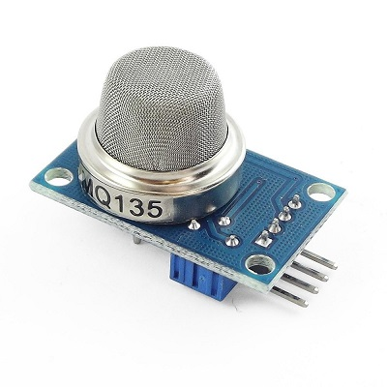

* Wide detecting scope
* **Detect/Measure NH3, NOx, Alcohol, Benzene, Smoke, CO2, etc.**
* Operating Voltage is +5V
* Analog output voltage: 0V to 5V
* Digital output voltage: 0V or 5V (TTL Logic)

**MQ7:**

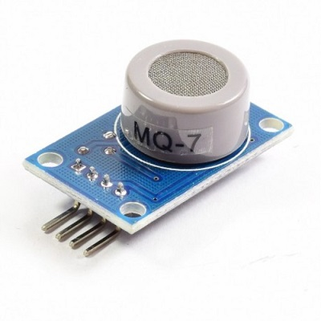

MQ-7 gas sensor is sensitive material used in clean air, low conductivity tin dioxide (SnO2). Detection method using low-temperature cycling (1.5V heating) detect carbon monoxide, airborne sensor conductivity increases with the increase of the concentration of carbon monoxide gas.

**• Testing gas: Carbon Monoxide**

• Detection of concentration: 10-1000ppmCO

• Loop voltage: 10V DC

**MQ2:**

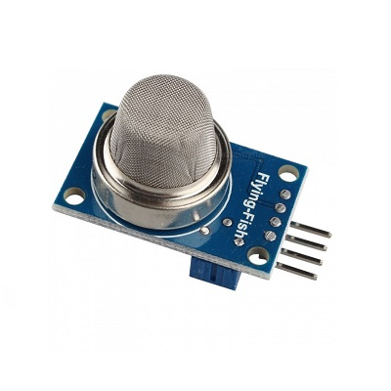

The MQ-2 gas sensor is sensitive to LPG, i-butane, propane, methane, alcohol, Hydrogen and smoke.

**Specifications:**

• Fast response and High sensitivity

**• Can detect Methane, Butane, LPG, smoke**

• Digital(HIGH/LOW) and analog(0V-5V) exit

• Voltage: 5V

• Power dissipation: 150mA

**Particulate Matter(PM) Sensor:**

**PM10 and PM2.5:**

This high precision dust sensor can also be used to measure PM10 in addition to PM1.0. PM1.0 isn’t the concentration standard commonly used by governments or agencies, but it’s just as, if not more important than PM2.5+. Get a reliable reading of dust concentrations between 0.3 to 10um using a light scattering analysis method. This method determines particle motion and density by measuring fluctuations in the intensity of scattered light. The microprocessor then calculates equivalent particle diameter and the number of particles with different diameter per unit volume. This technique enables users to measure very small particles, particles that fall below even 1.0um in size. We can measure: PM1.0, PM2.5, and PM10.0 concentrations in both standard & environmental units (# ug/m3).

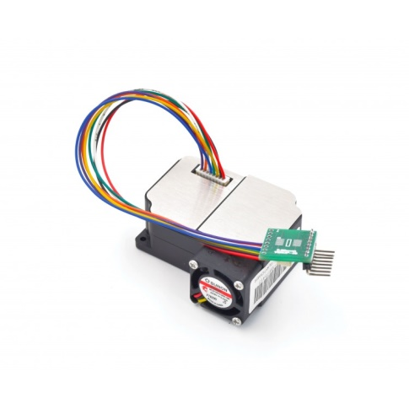

**Specifications**

* measurable dust diameter: 0.3-1.0 um, 1.0-2.5um, 2.5-10um
* Data unit: ug/m3
* Resolution: 0.3ug/m3
* Range: 0-999ug/m3
* Operating Voltage and Current:  5V, 200mA,
* Port: 3.3V TTL